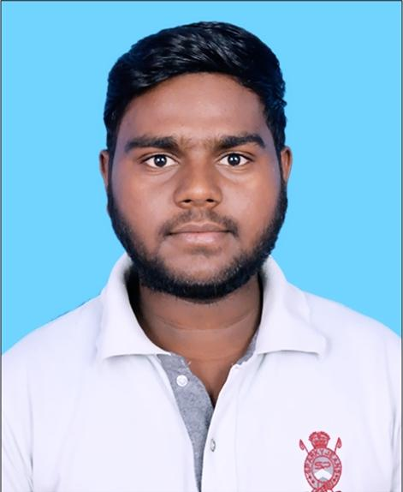PAWAN KUMAR

**Aryabhatta Knowledge University,**

**Mithapur,Patna**

📱+91-6206371039,+91-9608320037 **@** **pawankr27122001@gmail.com**

[**Linkedin**](https://www.linkedin.com/in/pawan-kumar-885713216) [**Hackerrank**](https://www.hackerrank.com/p1608) [**interviewbit**](https://www.interviewbit.com/profile/p1608) [**leetcode**](https://leetcode.com/p1608/) [**geeksforgeeks**](https://auth.geeksforgeeks.org/user/pawan1608/profile)[**CodeChef**](https://www.codechef.com/users/pawan1608)

| **EXPERIENCE**  [**Navprayas Family**](https://www.globalnpo.org/IN/Gaya/853378804796039/Navprayas-parivar)**,** Gaya (registered NGO) — Founder Member & *Treasurer*  May 2016 - present  Through this NGO, we take care of the studies of young children dwelling from remote areas and also provide them teaching free of cost. PROJECTS [**Sudoku Game Using OpenGL**](https://github.com/p1608a/SUDOKU-GAME)  July 2021 - Aug 2021  We Built a Sudoku game with the support of OpenGL, data structure, and backtracking  algorithm.  [**An Efficient Algorithm For Multiplication Using Vedic Maths**](https://github.com/p1608a/CODE-FOR-TWO-BIG-NUMBER-MULTIPLICATION-USING-VEDIC-MATHEMATICS)  July 2021 - Aug 2021  Using this algorithm, we can reduce the time taken for the multiplication of two large numbers by around 90%  [**Design Front-end for Navprayas Family’s Website**](https://drive.google.com/drive/u/0/folders/1cUdmPUdOkV74mfiLgIely5BC79b-EBuQ)  Designed front-end for Navprayas family’s Website using HTML and CSS.  **EXTRACURRICULARS / HOBBIES / STRENGTHS**   * Mathematicaphile, Social Work, Plantation, Playing Cricket, Writing Hindi Stories * Vediography,Photography | EDUCATION **Motihari College Of Engineering**  Sep 2019 - present **CGPA – 8.04**  **Gaya College Gaya,** Rampur Gaya (Bihar Board)  12th - APRIL 2017- MARCH 2019- **81.00%**  **Janta High School Bhaluhar Chaugain,** Gaya (Bihar Board)  10th - APRIL 2015- MARCH 2017- **81.00%** SKILLS  * **Strong:** C &C++, Data Structures, Algorithms, OOP * **Intermediate:** C#,JAVA,DBMS,SQL * **Beginner:** HTML,CSS,PYTHON * **Operating Systems**: Linux & Windows  RELEVANT COURSES UNDERTAKEN  * **Computer Science:** Object-oriented programming, Design & Analysis of Algorithms, Data Structures, Operating Systems * **ACHIEVEMENTS** * District 9th Topper and School Topper in BSEB 10th Board Examination. * Kick Start Round B 2022 Global Rank-2592 * CodeChef STARTERS37D Global Rank 30 Out Of 9730 Competitors * CodeChef STARTERS36D Global Rank 325 Out Of 10059 Competitors |
| --- | --- |